Section 4 – Prototype

OBJECTIVE | YES OR NO | JUSTIFICATION
Customers can create new accounts with secure username and password storage. | Yes | I will include this process in my prototype because it is a main process that will occur for all users of the system regardless of their role being a customer, admin, or staff. Although staff and admin will have already been made an account, it is important to test this out in advance because it will also be executed by customers. The creation of a password may require encryption, and therefore practicing this code would help me be more prepared when developing the system. Additionally, I need to practice linking SQL tables and importing this into Python, which is a task apart from this process.
Customers, staff and admin can log in and out of their account. | Yes | I will include this process in my prototype because it is a main process that will occur for all users of the system regardless of their role being a customer, admin, or staff. As this is a frequent process, it should be tested to ensure that I can program this feature efficiently and make it work.
Stakeholders can update their personal details (e.g., name, phone number, email). | No | I have chosen not to include this process because it is a fairly simple and short process that will require minimal code. Despite it being a common process for all users, it would just consist of users inputting their updated details and then the program updating their database.
Accounts are saved and retrieved correctly from the SQL database. | No | I chose not to program this because it is of low priority. I can practice SQL when dealing with data regarding the restaurant stock etc.
Admin should be able to create, change and delete all accounts.  They should be able to retrieve staff and customer information.  They should also receive the reports and metrics on the restaurants profit.  They also can update the menu, on the availability prices and ingredients. | Yes | As this is a main process required by Admins, this is a process I must prototype. The ability to create changes and delete all accounts is fundamental as it makes system management a lot easier.  Retrieving customer and staff information is also important so that details can be updated and invoices can be sent correctly, allowing me to practice the SELECT command in SQL.  Reports and metrics were a key objective from El Aziz themselves, so prototyping this feature and making sure it works as expected is going to prevent issues further down the software development.  Menu management is crucial, as it affects customer experience and El Aziz would like to enhance this. Prototyping in advance can allow me to experiment with the user interface design and consider UX principles while developing.
The system will display an interactive and categorised restaurant menu, organised into starters, mains, desserts and drinks. | Yes | This will be prototyped as it will allow me to prioritises user experience, aligning with El Aziz’s goals. It will also allow me to work with Tkinter and Python together, helping me develop a GUI. Practicing how to develop selection lists, drop down menus, buttons, icons, and more will prevent issues when I develop the actual software, making the program more efficient.
Users can view item details such as description, any allergens, price, and availability. | Yes | This will also be prototyped as it is a part of the menu display and management process. It will affect the staff, customers, and admin and therefore play an important role within El Aziz’s restaurant. Practicing how to allow customers to select an image and be shown a description of the dish, allergens etc. will optimise my programming later.
Menu data loads correctly from the SQL database and updates when items are changed or added by staff. | Yes | As I am prototyping the menu and practicing GUI development, SQL efficiency and more, being able to load data correctly will be a priority. This objective will be prototyped during the development of the menu processes.
Customers can select menu items to add to an order and customise them (e.g., size, toppings and special requests). | Yes | This process must be programmed in the prototype as it is a key process, containing primary keys. It is a frequent process that will be executed during the restaurant's business hours and therefore must work efficiently and accurately. This process will work with Python and Tkinter to make the selections from drop down menus, buttons, etc.
Orders can be edited or cancelled before confirmation. | Yes | This will be included in the prototype as it will need to be tested in advance. It is a required process and must work correctly allowing them to cancel an order, otherwise it could lead to negative customer experience and more complications.
Orders are correctly stored in the SQL database, linked to the customer’s account, and displayed in a summary screen. | Yes | Again, orders are a main item throughout the system running and ensuring that orders are made, stored, and retrieved correctly optimises the efficiency of my system. The order being displayed on a summary screen implies the receipt, and this being prototyped will allow me to practice designing and developing pages that consider UX experience which will enhance my systems functionality. It will allow me to practice the use of lists, calculations, and retrieval.
To calculate the total of the order an algorithm that can link the costs of their reservation, order and possibly a tip must be implemented. This should be outputted through a receipt. | Yes | This feature will be prototyped because feedback I gathered from the previous system was that calculations were inaccurate and were causing a lot of issues. Therefore, prototyping this in advance to the real development will allow me to develop a system that has accurate rounding and calculation for costs and that this is specific for the order made depending on the items bought and their quantity.
Customers can make, view, edit, or cancel table reservations. | Yes | This is a yes because it is a basic yet fundamental part of the restaurant working. Practicing how to edit orders by deleting or appending items now will allow me to program this in the most efficient and short way.
System prevents double-booking by checking table availability in real-time. | No | Although this would enhance the system, this is just another form of verification or validation to make sure the same reservations aren't made twice for two different people. It is a really short process and doesn't need to be prototyped as it is straightforward checks made to ensure a reservation is available.
Reservation data is validated and stored accurately in an SQL reservation database, ensuring no overlap in booking times. | No | This will not be prototyped as validating and storing data securely with SQL will have already been prototyped but with other features/processes of the system. Also, since I am not prototyping the double-booking prevention part, I will not prototype this.
Customers can submit feedback through a simple form after placing an order or visiting the restaurant. | No | This is a feature that I will not be prototyping because it is not necessarily required. It is a final process a customer may choose to do, as it won't be mandatory. It will also just be a simple form, so this isn't too important that I will have to prototype this now.
Feedback includes ratings (1–5) and optional comments. | No | Since I am not prototyping the feedback form, this rating task will also not be prototyped for the same reasons.
Feedback entries are correctly saved in the SQL database and retrievable for reporting. | No | This won't be prototyped because it just isn't as important as the other features. This won't affect customer experience and how the business runs.
Staff can generate reports on sales, most popular items, reservation trends, and feedback summaries. | Should be admin in investigation  Yes | This is something I intend on prototyping because it contains procedures and tasks, I have no experience coding in. For staff reports and analytics I may have to download a library to use and therefore this should be tested beforehand.
Reports are displayed in the GUI and can be exported (e.g., text file) | Yes | This is something else I will prototype as it is of new skill to me, I have not programmed a feature like this before so doing this beforehand can help minimize errors when developing the software.
Reports display accurate, up-to-date data from the SQL database. | Yes | Ensuring data is up to date is crucial in the restaurant's performance, so this must be prototyped to ensure customer orders and reservations won't be mishandled.
All data (accounts, orders, reservations, and feedback) is stored securely in the SQL database and backed up externally. | No | I will be prototyping this in different procedures like making the customer orders and making reservations so technically this will be prototyped just embedded with other tasks, so it doesn't need to be prototyped by itself.
Passwords are stored using encryption. | Yes | This is a feature that I have not programmed before, so it would be useful to prototype. It also enhances the security of the system, aligning with the objectives.
Validation is put in place for login. | Yes | This will be prototyped because it is a small feature that, despite not being as important as other features, still plays a role in data security which is something El Aziz wanted to enhance.
Backup files can be created and restored successfully | No | This is of low priority and is not needed in the prototype.
The GUI will use a consistent and accessible colour scheme suitable for all users. | No | This is also a low priority because the prototype intends to test the functionality and operation of the system, not the appearance.
UX should represent the restaurant through colour schemes, logos and images. | No | This is not necessary in the prototype.
When the system is loaded, they should be shown a GUI which asks for their login. Depending on their access level, they will be shown different options. | Yes | This is going to be one of the screens after an output, therefore this should be prototyped to ensure that it will display the correct outputs in order and work swiftly.
Navigation will be intuitive, with clear button labels and prompts. | Partially | This will partially be prototyped as I won't be making the buttons colourful and meaningful. However, I will be creating buttons allowing users to progress into the restaurant experience.
UX design will be inclusive and consider those with disabilities or special needs. | No | This is a low priority. I intend to test the functionality and operation of the system.
Admin should be able to create, change, and delete all accounts. They should be able to retrieve staff and customer information. They should also receive reports and metrics on the restaurant's profit, as well as notifications and data on stock levels. They also can update the menu for item availability, prices, and ingredients. | Yes | This will be prototyped as it is a high priority in the system. Allowing the admin to be presented with their tasks and permissions and receive and input data for such permissions is important in the performance of El Aziz. I must make sure these processes work and can be programmed efficiently.
Customers should be able to create and edit an account. They should be able to request that their order or reservation be cancelled or rescheduled. They should be able to create, customise and edit an order before purchasing. They should receive confirmation of their order and reservation via invoice. | Yes | This will be prototyped as it is a high priority in the system. Making sure customers can access their permissions independent of the restaurant and also successfully make orders and reservations will enhance their experience. I must make sure that these procedures are implemented efficiently.
Staff should be able to create, edit, and delete their accounts. In terms of waiters and waitresses, they should be able to retrieve customer orders and the customer’s information to deliver it to the correct customer. They should also be notified when a table needs assistance. They should also be able to access the reservation database to set up in advance. Chefs should be able to access the database on customer orders to cook the correct meal and the statistics on how many customers they currently have and are expecting. Staff, chefs, and cleaners should be allowed to access their work shift through their account. Cleaners should have access to see which reservations are in use. | Yes | This will be prototyped as it is a high priority. Ensuring staff can manage their accounts while also monitoring and observing incoming data will make their jobs easier and more efficient. Also being able to assign levels of access to different staff members will allow me to consider access levels and data security precautions. I need to make sure I can prototype these functions and ensure they function correctly.

Prototyping & Annotations:

MAIN SCREEN:
The name of the tab/window is El Aziz, to organise the windows.

Home page/menu for users. First introduced to create an account or login if they already signed up.

Big bold heading, welcoming the user.

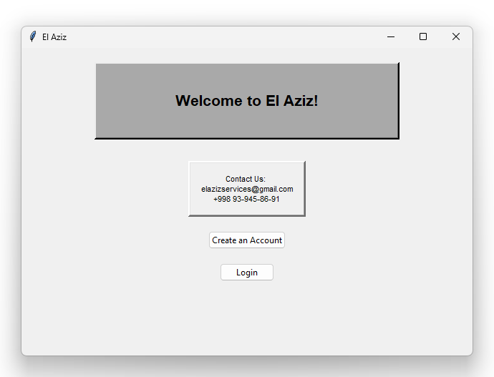

Box of El Aziz’s contact information closed off to separate and organise the texts.

Button to Create an Account

Button to Login

There is a lot of empty space to not overwhelm the user. Dull colours to not overwhelm the user as well. A simple yet functional format.

Meets the objective of making an easy interface to use and understand. A lot more organised.

Once the user has pressed the ‘Create an Account’ button, they are taken to this window. They select their role as a user by selecting the box that applies to them. They are then required to enter information regarding themselves, like their name, email address, and phone number. They are then required to create a username and password. They will then press the ‘submit’ button, and the data is saved to the El Aziz database in the folder depending on the role they selected.

Bold heading labelled with ‘Create Account’ informs user of the process.

New window opened indicates new process (still labelled ‘El Aziz’).

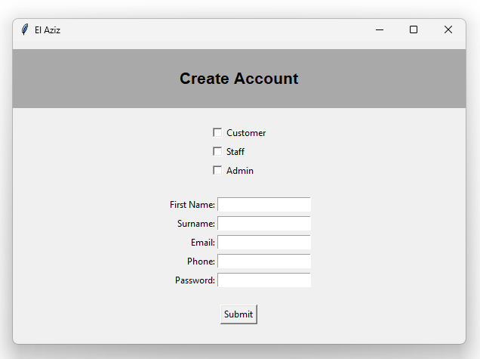

A process of selection. Tick the box that applies to the user role.

Fields of entry required to successfully create an account. Validation will be embedded to ensure specific data types are used and all inputs are sensible.

User’s selection and account details is saved and stored in the accounts database.

User types in their input and then submits their entries.

Button to Submit inputs.

Minimal UX design, a lot of empty space to reduce overwhelming feeling.

After the user has submitted their entries for their new account they have created, they will close down this window and go back to the main menu. Behind the scenes, once the user had submitted their entries and selection, it was written to the accounts database as one account. This will become useful for when the user wants to manage their account. The user will then open the ‘Login’ window by clicking the ‘Login’ button. Once they have done so, they will be taken to a new window to log into their account.

Main menu task therefore the UX is different to those tasks specific to the role. This headings bar is across the width of the window instead of just a box.

New window indicates new process. This window is still labelled “El Aziz” as the task belongs to El Aziz.

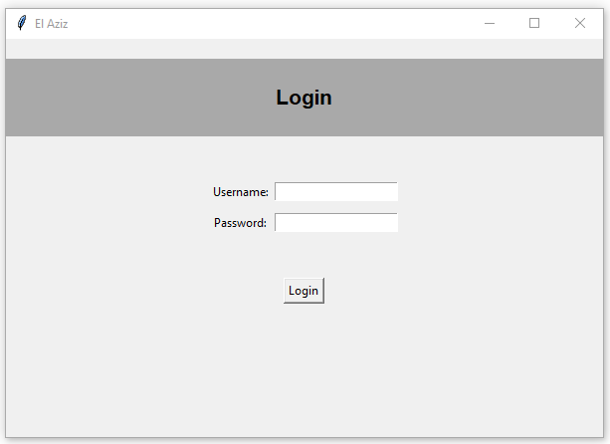
When password is typed into the bar, it is encrypted and hidden by presenting ‘*’ instead of the actual letters. This is a security measure.

Entry for the user’s username and password to login. User must type and enter these details

Minimal user interface, a lot of empty space. Makes the task feel a lot simpler and straightforward.

Bold heading informing the user of their current process under completion.

Click ‘Login’ button to successfully login, then you are taken to your dashboard depending on the role selected when creating the account.

In this prototype, no validation was added as it was unnecessary for a prototype, however in the real software, validation will be embedded to ensure security and safety of the system. Once the user has successfully logged in, the new window of their dashboard will automatically open and they will be taken to this page. They will have to close the previous login window. Then the user will be able to proceed with tasks depending on their role. Each role will be presented with a dashboard as there are 3 dashboards in this system: Customer, Staff and Admin. Some procedures will overlap with the 3 roles and will share similarities.

CUSTOMERS POINT OF VIEW:

New window indicates new process. This window is still labelled “El Aziz” as the task belongs to El Aziz.

This heading is now a box with the text inside as it is for the user’s dashboard. The heading welcomes the user to their dashboard, informing them of their tasks.

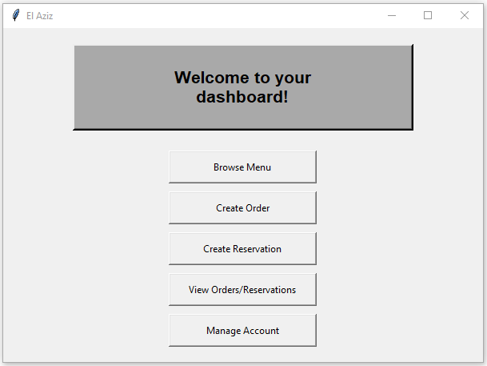
Button to view orders and reservations made. Useful for tracking. Simply displays the order and reservation details. All displayed in a separate window.

Button to create a reservation. Taken to a separate window to complete this task.

Dashboard tasks (buttons) specific to role within the system use. Customers will make orders and reservations as their main tasks.

Button to create an order. Taken to a separate window to complete the task.

Button to browse El Aziz’s menu. Taken to a separate window to view menu.

Could add the users name in the text so it says “(name), Welcome to your dashboard!” This way it is more user focused and engaging.

Despite the list of tasks to complete through buttons, I have tried to keep a minimalistic design to not overwhelm the user. Make it as clear as possible of what tasks to complete.

Button to manage account. Simply displays all account details in a separate window, independent of this dashboard.

Once the user has clicked any of these buttons, the task will be proceeded in a separate window. Each task will have its own window for the organisation of the system and make it easier to maintain and complete. Once you complete a task/process, you can come back to the dashboard to complete another.
Different heading for the tasks specific to the user dashboard. Introduces the customer to the menu, informing them of menu items, description, price and category.

New window indicates new process. This window is still labelled “El Aziz” as the task belongs to El Aziz.

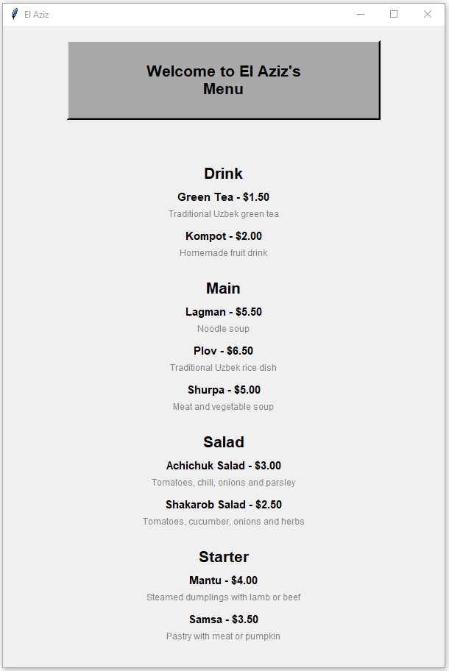
Once the user has decided what they like to order, and is done with the menu, they will close this window down and go back to the dashboard to create an order. This could be more efficient with back buttons.

A little section of the menu categorised into the drinks offered. Displays the item name followed by its price in USD. It then writes a short description of what the item is to inform user.

A little section of the menu categorised into the starters offered. Displays the item name followed by its price in USD. It then writes a short description of what the item is to inform user.

Ideally, the starter should be at the top and the drinks at the bottom, so this is something I need to reorder for the users experience and to make it more convenient.

A little section of the menu categorised into the drinks offered. Displays the item name followed by its price in USD. It then writes a short description of what the item is to inform user.

Despite the long menu of items, I have tried to leave a lot of empty and blank space to make it clearer to read the information. Trying not to clutter or distract the customer.

A little section of the menu categorised into the main dishes offered. Displays the item name followed by its price in USD. It then writes a short description of what the item is to inform user.

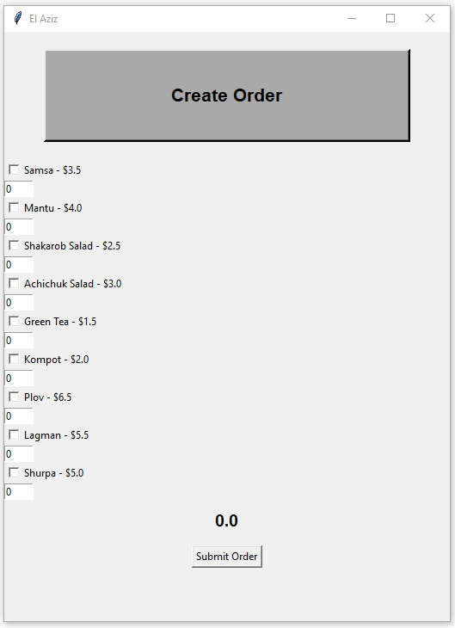
Once complete and submitted, return to your dashboard by exiting this window. Customers will now wait for their food to be ready.

The small squares demonstrate bars for selection. The customer will select the square, ticking it, if they want to purchase that menu item.

$

As the user selects menu items and specifies the quantity of each item, the total will change from its default value of 0.0 to its total cost. The total will automatically update in real time depending on menu items added

Button to submit the order. Once complete and submitted, return to your dashboard by exiting this window. Customers will now wait for their food to be ready.

Left a lot of blank space around the selection of items to not overwhelm the user and allow them to clearly see the item names.

The field of entry with its value already set to 0 is changeable and allows the customer to change it to specify the quantity of each menu item they want to purchase.

The UX design could be more efficient by centring this list of items in the middle. Having it all to one side looks odd.

Lists all the menu items without categorising them, just written in order.

New window indicates new process. This window is still labelled “El Aziz” as the task belongs to El Aziz.

Different heading for the tasks specific to the user dashboard. Informs the customer of their task, this being to create an order

Once complete and submitted, the user can exit this window to return to dashboard.

New window indicates new process. This window is still labelled “El Aziz” as the task belongs to El Aziz.

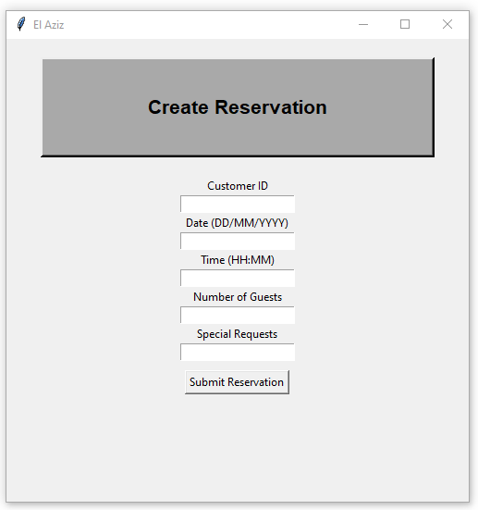
A lot of empty space, simple user interface and easy to navigate.
Button to submit reservation, once complete you need to exit the window.
Should add text messages in small window informing the user if a task has been successfully completed or submitted. Triggered by clicking the submit buttons.
For the date and time, it specifies the format the system requires. Explains their instruction to the customer, demonstrates communication.
Bars for entry, allow the user to annually type and enter their details to satisfy the requirements to make a reservation.
Dark and dull colour, black outline of box and bold text stands out to the user’s eye, more visible to see.
Heading informs the user of their current task/process to complete, in this case to create a reservation.

For these processes like creating an order and reservation, once they have submitted their entries, the data is stored in their allocated database. The database will store the specific fields data like their reservationTime inputted or their itemQuantity specified. This is all stored alongside the customerID which allows us to assign the order or reservation to the customerID instead of trying to find their name. The customerID is more specific to the customer and reduces confusion in the case we have multiple of the same names.

Once complete and the user has viewed their details, they can exit this window to return to dashboard as there is no back button.

New window indicates new process. This window is still labelled “El Aziz” as the task belongs to El Aziz.

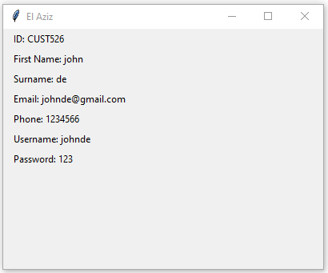

Displays their ID. Doesn’t exactly specific their role they selected, however it is implied in their unique ID.

Simply lists and displays all the account details from when they created their account.

A lot of empty space, and this is displayed in a smaller sized window due to the small volume of data to display.

Password is clearly visible and not encrypted. Too enhance the security of this system, could add the option to hide and unhide the password which would require some method of verification.

STAFF POINT OF VIEW:
Once complete and the user has viewed their details, they can exit this window to return to dashboard as there is no back button.

New window indicates new process. This window is still labelled “El Aziz” as the task belongs to El Aziz.

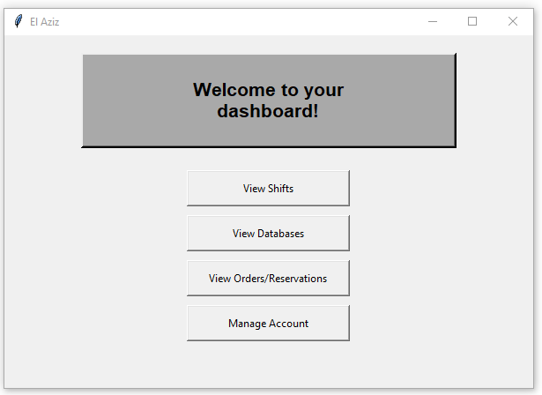
Tasks are different to a customer dashboard. Members of staff have access to view their shifts and view databases relevant to their daily tasks and responsibilities

A lot of empty space to emphasise the tasks listed already on the dashboard.

Could add the users name in the text so it says “(name), Welcome to your dashboard!” This way it is more user focused and engaging.

This heading is now a box with the text inside as it is for the user’s dashboard. The heading welcomes the user to their dashboard, informing them of their tasks.

For viewing orders & reservations, it will be displayed the same however will be a lot more overwhelming as their will be a large volume of data.

Similar tasks of viewing orders & reservations and managing their account. It will display these in the exact same way, by simply printing out the details.

Once the user clicks on one of these buttons, all tasks are completed externally of this window. Each task is completed in a separate window and once complete they exit the window to return to their dashboard.

ADMIN POINT OF VIEW:
Could add the users name in the text so it says “(name), Welcome to your dashboard!” This way it is more user focused and engaging.

New window indicates new process. This window is still labelled “El Aziz” as the task belongs to El Aziz.

Once complete and the user has viewed their details, they can exit this window to return to dashboard as there is no back button.

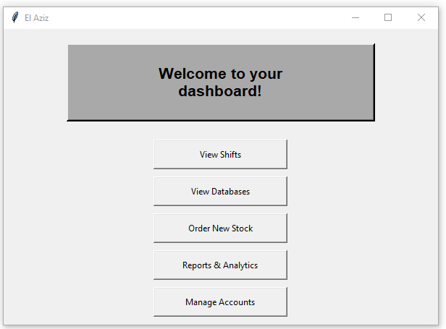
To order new stock, admin will have access to view the Stock database, and will be presented the data in descending order to rank the urgency of menu items. They will then be able to add stock to their cart and order it.

A lot of empty space to emphasise the tasks listed already on the dashboard.

Tasks are different to a customer and staff dashboard. Members of Admin have access to everything on the system as their responsibility is to manage, maintain and overlook the system. This gives them unrestricted access rights.

Similar tasks like viewing shifts and databases, however as this is the Admins POV, it will be exaggerated and to a larger scale of data. They will be able to view ALL workers shifts and ALL databases of the system.
This heading is now a box with the text inside as it is for the user’s dashboard. The heading welcomes the user to their dashboard, informing them of their tasks.

For reports & analytics, the admin will be presented their data in different forms. They will be shown graphs of their monthly sales, profit and losses, as well as their in demand menu items. Data will be clearly presented for the admin to view. Reports will be generated as well.

To manage accounts, the admin will be able to view ALL accounts and their details on the system. It will simply be printed/displayed in a database. They will be able to view the ‘Accounts’, ‘Customer, ‘staff’ and ‘admin’ database.

Once the user clicks on one of these buttons, all tasks are completed externally of this window. Each task is completed in a separate window and once complete they exit the window to return to their dashboard.

Discussion of Prototype:
After completing my prototype of what I would like El Aziz to appear and function as, I will now discuss my thought process and considerations and decisions I made that resulted in change.
Firstly, I removed the first output screen completely that I had designed form the program. I realise that this was inefficient and unnecessary as it was just a waste of a window and not functional. Instead users were prompted to login or create an account first and then when creating an account they were able to select their role within the system. Moreover, if users logged in they would’ve already been assigned an ID that is specific to their role. Secondly, I expanded the menu for El Aziz, specialising in salads and additional dishes that they offer that I was not aware of initially, therefore there are new dishes listen on the menu. I also wrote a short description of each menu item to inform the user of the dish and paint the picture for them to help them decide if it was worth purchasing. Thirdly, I also changed the ‘Create Order’ feature as the format of my design was too difficult to program for me. I was inexperienced with drop down menus, and manually adding items to the order seemed to time consuming. I wanted to make this process as efficient and quick as possible. Instead of creating a drop down menu, I decided to list all of the menu items and enable users to select the item and then specify the quantity for each item. This was a lot more feasible for me to program and simpler for the user in my opinion. Then, the program would be able to automatically calculate the total, display this and allow the user to confirm their order.
Initially, I stated in my table that I only intended on prototyping certain features such as:
- Admin should be able to create, change and delete all accounts, retrieve staff and customer information and receive the reports and metrics on the restaurants profit.
- They also can update the menu, on the availability prices and ingredients.
- Orders can be edited or cancelled before confirmation.
- Staff can generate reports on sales, most popular items, reservation trends, and feedback summaries
- Reports are displayed in the GUI and can be exported (e.g., text file)
- Reports display accurate, up-to-date data from the SQL database.
- Admin should receive notifications and data on stock levels. Update the menu for item availability, prices, and ingredients.
- Staff should be able to create, edit, and delete their accounts. In terms of waiters and waitresses, they should be able to retrieve customer orders and the customer’s information to deliver it to the correct customer. They should also be notified when a table needs assistance. They should also be able to access the reservation database to set up in advance. Chefs should be able to access the database on customer orders to cook the correct meal and the statistics on how many customers they currently have and are expecting. Staff, chefs, and cleaners should be allowed to access their work shift through their account. Cleaners should have access to see if reservations are in use.
- Customers should be able to create and edit an account, request for order or reservation be cancelled or rescheduled, create, customise and edit an order before purchasing. They should receive confirmation of their order and reservation via invoice. Customers should be able to view their order and reservations.
However, as time went on and the code became bigger, I began running into a lot of issues with time management and code optimisation and efficiency which led me to cut some of these features out rom the prototype. Overtime, I began to realise that for me, the prototype was to test the GUI efficiency and assess whether I was able to program selection, or entry for fields etc. The GUI windows, the lists, the headings, all of these features are the foundation of my design, my system and of El Aziz. Therefore, I decided to prioritise this over the other features. The GUI was something I was inexperienced with whereas the process and functions within the program were things I could pick up on easily. Therefore, I prototyped less features for this program as it was unnecessary and resulted in me going over time. The prototype still demonstrated important functions and processes like logging in, creating accounts, making orders and reservations etc.
In my prototype, I had prototyped features like customers being able to view their orders and reservations. The intention was for it to simply display their details in the same way the account details are displayed under the manage account task. However, I experienced a lot of issues when programming this feature, and also ended up struggling to fully debug this section of the code. Therefore, I left it alone and didn’t end up fully finishing this prototype. Similarly, I had programed the create order function however had issues with submitting the order. Despite both these sections being customer focused features and important, I understand that my prototype was to experiment with the GUI and TKinter. Both features were displayed appropriately, their processes just weren’t efficient or functional. However, acknowledging these failures early on can prepare me for the future development and understood where I went wrong, to improve my system and programming.
As the system of El Aziz, is a customer focused system, I believed it was crucial to prioritise the customer end of the system over the admin and staff. Some features mentioned in the list may have been partially prototyped however, some were completely not prototyped. My reasoning for some being left out of the prototype was that, it was too large or complex of a feature to program for something that was just a test. With features like generating reports, or viewing live databases, I was unsure of how to program them in the most efficient and quickest way possible suited for a prototype. Trying to program these features that are not customer focused, when I had already spent a lot of time creating the GUI was just not necessary based on my judgement.
However, with leaving these features out of my prototype, it does leave some uncertainty of how it will function alongside the rest of my system. With the non-prototyped features, it does increase the chance of errors and incompatibility with the rest of my program, however I intend on putting my best efforts into this system for my client. Now that I have practiced and prototyped the basics of creating a GUI, I hope to program my official El Aziz GU efficiently and quick enough to spend more time programming the specific features essential and desired by the owner of El Aziz.
Good Features:
- GUI Functionality:
The GUI is functional and displays buttons, icons and other components clearly and as preferred. It allows users to follow the instructions and fully go through the process of ordering and making reservations easily and smoothly.

- Gathering user input:
The GUI gathers user input in a variety of ways from entry, selection and drop-down menus. The range of user interaction helps keep the user engaged and makes collecting data easier for El Aziz.
- System Efficiency:

The prototype has been programmed in a way that satisfies all user groups. It makes task completion and identification a lot easier and allows each user category to view different things depending on their status. It helps with efficiency but also safety as it establishes access rights and user permissions which prioritises safety and security of the system.

Shortcomings:
- Screen/Window Formatting:
The screen size is fixed and doesn’t adjust to the content displayed on the window. This limits usability and functionality.

- No Scrollbar:
The absence of a scroll bar means that the user cannot fully view all items and options on the menu. This relates to the issue of the screen and window formatting because the user must physically readjust the window to fully view the items which are inconvenient and inefficient.

- User Experience:
The use of dark/monotone colours may dissatisfy users. It isn't engaging and doesn't fully represent El Aziz due to the lack of images and colour. It could also directly address users more by using their name in the “Welcome to your dashboard!” heading of the window, to make it feel more personal. Also, alerting users when a task is successfully complete or failed in a simple message would be useful.

- No return/back buttons:
The absence of the back button is really inconvenient as users will have to physically locate the exit button at the top right of a window to then navigate their dashboard or previous window. This could all be optimised and made more efficient by having a simple ‘back’ button that will take users to the previous page quickly.
Suggestion for Improvements:
I would a choose to implement certain features like dynamic windows/screen sizes to allow users to adjust depending on the contents displayed. I would also consider adding a scrollbar to allow users to view all contents on the screen without having to readjust the windows size. This will be more convenient for users as it will allow users to adjust their view for windows that are typically taller in length, like the menu window. When you first view the menu, the volume of text on the window doesn’t fit the window dimensions, so it could be easier to scroll up and down.
Additionally, a shortcoming of the prototype was the user experience. Initially, I thought that the dull colours and minimalistic theme were a suitable choice, however my client discussed that the user interface and design wasn’t representative of El Aziz. He argued that the lack of vibrant colours would bore customers and not engage with customers enough, which would decrease user satisfaction and engagement which could cause a massive loss on the business. He suggested using vibrant colours in alignment with their branding to be more representative. Moreover, the incorporation of images in the system could be more visually appealing but also beneficial. For certain tasks like the menu, displaying images of the dishes and menu items next to their writing would allow users to gain a first impression on the food before deciding if it’s worth purchasing. This also demonstrates honesty and truth which is a good look on El Aziz. Another thing that I noticed in the system was the lack of direct addressment. By personally addressing customers or users by their names, shows an element of communication and makes the user feel valued within the system. It is something small, however could create an impact on the system. Whilst prototyping, I realised that when you click ‘submit’ at the bottom of each window to submit a task, it doesn’t inform the user if this process has been successfully complete or if it has failed, which is inconvenient for the user. By implementing error messages and successful completion messages in small windows that are triggered by clicking submit, it would be informing to the user and allow them to continue forward with the next task, or go to the failed task and correct it.
Moreover, a valid point mentioned in the shortcomings was the absence of ‘back’ buttons. During the prototyping stage, I found myself constantly having to manually exit windows to return to a previous page. Ultimately, I was getting mixed up with windows and accidentally existing the wrong windows. This could negatively affect the user experience. To combat this, by implementing a simple back button at the corner of each window where the user is directed to the previous page to return to their dashboard after completing a task. This would be a lot more efficient. In the same way, I could also implement a forward button, which can take you to the next window to get ahead of task completion. Both features are incredibly useful and efficient, which could optimise my systems functionality.
In conclusion, these features being embedded in the final program of El Aziz’s restaurant system could be beneficial and enhance the systems efficiency and optimisation, meeting the set objectives.

